**Module IV: Common Hardware problems and Trouble shootings**

* Starting point for troubleshooting
* Replacement Method
* Common Hardware problem and their solutions
* Mouse
* Keyboards
* Power supply
* Motherboard
* Main memory
* Hard disk
* Sound card
* Modem card
* Monitors

**STARTING POINT FOR TROUBLESHOOTING**

Every technician [computer users] has his or her own way to troubleshoot. Some people use their instincts while others need an advice from other people. **But let** us see a common troubleshooting method.

**POINT 1. GATHER INFORMATION**

* Ask the customer the following questions to define the problems:
* Can you tell me something about the problem?
* What did you do to your computer lastly [Before it stopped working]?
* How often does this happen? Have you installed new software Have you deleted some files?
* Have you added a new hardware device?
* Have you made any other changes to the computer recently?

**POINT 2. CHECK THE POWER AND CABLE CONNECTORS**

* Check the power line.
* Check the wall outlet power.
* Check the power sockets.
* Check the cables.
* Is it plugged in?
* Is it turned on?
* Is the computer ready to accept command from the user?
* Open the case covers and Reset chips and cables.

**POINT 3. CHECK IF THE ERROR IS USER'S ERROR**

* Because the user cannot print.
* Because the user cannot save the files
* Because the user cannot run application etc.

If the user is wrong, show him \ her how to use the computer.

**POINT4. RESTART THE COMPUTER**

This process is called a "cold boot" (since the machine was off or cold when it started). A "warm boot" is the same except it occurs when the machine is rebooted using {CTRL+ALT+DELETE}.

***NOTE:*** *-Reboot can solve or show the problem. Rebooting doesn't work, try to power down the system completely, and then power it up*

**POINT 5. DEFINE IF THE PROBLEM IS A HARDWARE OR SOFTW RERELATED**

* Is it a startup problem?
* Is it windows problem?
* Is it a program problem?
* Is it a device problem?

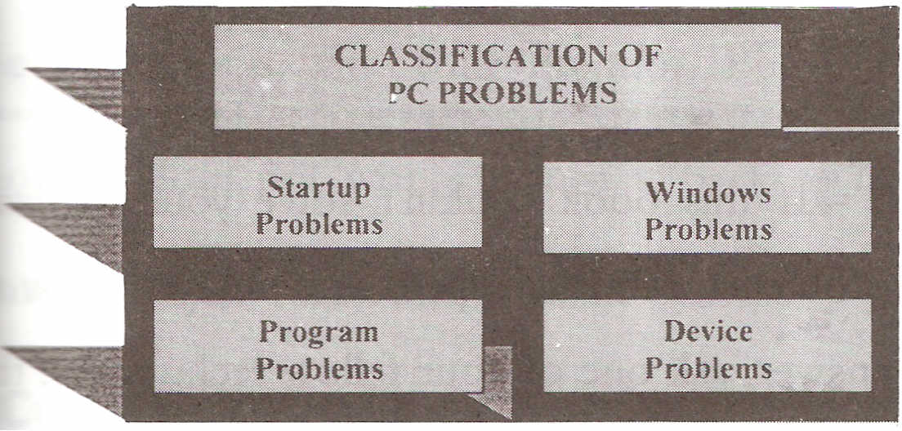

**Startup problem:** *An error occurs before or during boot process.*

**Window Problem:** *An error occurs with window system itself.*

**Program Problem***: An error occurs with a specific program.*

**Device Problem:** *An error occurs with a specific piece of hardware parts.*

**POINT 6. FIND OUT THE PROBLEM AND SOLVE IT!**

* **If** the problem is hardware related, determine which component is failing and try to solve the problem.
* **If** the problem is software related; determine which is corrupted or missed and try to solve the problem.

**REPLACEMENT METHOD**

When you troubleshoot, make one change at a time is my favorite troubleshooting method). **If** the change does not solve the problem, change it back to its original state before making another change.

For example, you may have trouble on your monitor. If you can get another monitor, attach to your system and try it. If the other monitor works, you know that the problem is with your monitor. But if the other monitor does not work, change it back to its original state and try to find other possible causes.

**Common hardware problems and their solutions:**

* **Mouse**
* **Keyboards**
* **Power supply**
* **Motherboard**
* **Main memory**
* **Hard disk**
* **Sound card**
* **Modem card**
* **Monitors**

**Mouse problems and solutions**

**Problem:**

* **The mouse may hang up or may not move in the correct way due to dust. [Doesn’t work properly]**

**Solution**

Clean the mouse [mechanical mouse]:

* Shutdown the PC.
* Remove the mouse cable from its connection at the back of your PC.
* Turn the mouse upside-down and remove the securing screws from the mouse case.
* Remove the mouse ball from the cavity.
* Clean the cavity and the mouse ball with proper available materials. [ use dry cloth]
* Look inside the mouse housing. You will see the two perpendicular bars. Use your finger nail to scrape along each bar, removing any dirt.
* Reconnect the cable to the computer.
* **Turn** ON the PC and see that if it is activated.

**Problem:**

* The new PS/2 or serial mouse doesn't work when plugged on the system running Windows XP**.**

**Solution**

* Restart the system.
* Plug the new mouse firmly.
* Restart the PC.
* The new mouse will be active.
* Else-use a replacement method.

**Keyboard problems and solutions**

* **While working on PC, something (liquid) Spilled in to the keyboard.**

**Solution**

* Remove the keyboard cable from its connection at the back of the PC. Do not wait!! You need to cut power to the device in order to avoid a possible short circuit.
* Shutdown the PC using the mouse [start>turn off computer ...].
* Tip the keyboard upside down and drain out as much of the liquid as you can.
* Try to dry the inside part of the keyboard properly by using blow dryer or direct sunlight.
* Reconnect the keyboard cable to the computer.
* Power up the computer and manipulate the keyboard to assure proper functioning.
* **Some keys on the keyboard don't work.**

**Solution**

For the current help:

**Use On-Screen Keyboard. [Win XP]**

To open On-Screen Keyboard: click on Start, point to Programs, point to Accessories, point to Accessibility, and then click On-Screen Keyboard. Then you can use the mouse to type any text.

**OR**

* Turn OFF the PC and Remove the keyboard cable from its connection at the back of the PC.
* Turn the keyboard upside-down and remove the securing screws properly.
* Select the key that you want to remove. Just be careful not to damage the other key.
* Clean or adjust the sit of the key properly.
* If you remove multiple keys, be sure to return them to their proper seats.
* Make sure· that the keyboard is dry while cleaning.
* Replace the cover.
* Reconnect the cable to the computer.
* Boot up the PC and check that if activated.

**CPU problems and trouble shootings:**

**Problem**

Both the CPU and power supply fan work Properly but the system shows a blank screen.

**Solution**

The CPU might be damaged. Use the replacement method.

**CPU problem Possible causes:**

* Overheating.
* Static discharge.
* Bent or Broken pins.

**General symptom of CPU**

* The system fails to Boot (start).
* Black Screen.
* The system boots, but the operating system (windows) fails to load.
* The system locks-up or dies after several minutes of operations.
* The system says "hardware monitor error ..... "

**Memory problems and trouble shootings:**

**General symptom of RAM**

* The system refuses to do another task until you close some windows program.
* Slow down in operation.
* The system freezes.
* Creates [shows] the ghost and crashes pictures on the screen.

**General Troubleshooting**

* Check the virtual memory.
* Check the capacity of your RAM.
* Use the replacement method.
* Run any memory diagnostic software that is supplied by your computer manufacturer.

**Problem**

* The system displays blank screen with a long [multiple] beep sounds.

**Solution**

* The memory is not installed correctly [or the RAM is absent] .
* Press the RAM firmly on the motherboard.
* Or there's a problem with your memory or motherboard.
* Else-Use the replacement method.

**Problem**

* Some PC shows 200 series error any error (from 200-299) code during the POST process**.**

**Solution**

* Any number starting with 2 usually indicate memory-related problem.
* Check the memory setting into the BIOS set on
* Use the replacement method.

**Problem**

* A PC shows memory size error

**Solution**

* Memory size error always (usually) hap] **after** memory has been added. Running BIOS setup program will allow the system recognize the memory and the error should away.
* If the system is out of memory, add a memory stick (RAM) to increase the memory capacity.

**Problem**

* A PC shows memory parity error that halts the system operation

**Solution**

* If you get a parity error message, write down any memory address information that appears. If the problem occurs again, then the RAM is bad. Replace the RAM]

**Power supply problems and trouble shootings:**

**General power problems**

The general power problems can be categorized in three types:

**1) Power Quality problem**

**Possible causes:**

* EMI (Electro-Magnetic Interference] .
* Variable rate [frequency] from the power line.,

**2) Too much power**

**Possible causes:**

* Power spike [for few milliseconds].
* Power surge [for several seconds].

**3) No-enough power**

**Possible causes:**

* Power sag [for few milli second]
* Brownout [if sag lasts for longer than a second]
* Blackout [a complete of power failure]

**Protection against power problems**

You can use the following devices for proper

* Line conditioner
* Stabilizer
* Surge suppressor
* UPS

N.B upsmeans U ninterruptible *Power 5uppfy. T*he UPS is also known as battery backup

**Problem**

* Monitor's power indicator lights but no power lights on the system unit.

**Solution**

* Check the system unit's power connection.
* Check your power supply DC volt outlet.
* Use a replacement method for power supply.
* Check also the motherboard.

**Power supply symptoms**

* Fan noise sounds rough or louder than usual.
* Fan noise is absent altogether.
* The power supply chassis is unusually hot to touch.

**General troubleshooting methods**

* Check the power cable.
* Check the power supply [you can use a Multi- meter to test electronic components]. Check the power outlet voltage.
* Replace the power supply unit.

**Problem**

* A PC accidentally reboots or shutdown

**Solution**

* Check your power line.
* Make sure that your power supply is rated [watt" to handle all the peripherals that it powers [30Owatt or above is better]
* Check the power supply fan movement. • Use a replacement method.
* BIOS beep codes during POST
* POST- the Power on Self Test is the initial set of diagnostic tests performed by the computer when powered on.

|  |  |
| --- | --- |
| **Beep Code:** | **Description of Problem:** |
| No Beeps | Short, No power, Bad CPU/MB, Loose Peripherals |
| One Beep | Everything is normal and Computer POSTed fine |
| Two Beeps | POST/CMOS Error |
| One Long Beep, One Short Beep | Motherboard Problem |
| One Long Beep, Two Short Beeps | Video Problem |
| One Long Beep, Three Short Beeps | Video Problem |
| Three Long Beeps | Keyboard Error |
| Repeated Long Beeps | Memory Error |
| Continuous Hi-Lo Beeps | CPU Overheating |

**Motherboard problems and trouble shootings:**

**Problem**

* The PC shows 100 series error (any error from 100- 199) code and freezes the system.

**Solution**

* Any number starting with 1 usually indicates system board problem.
* Check the system board (motherboard)
* Use a replacement method.

**Problem**

* The power supply works properly' but no movement of the CPU fan and the display shows black screen.

**Solution**

The system board power connector is plugged incorrectly or the motherboard failure might cause this problem.

Problem: CLOCK that won't keep correct time. >>Be sure to check/change the battery.

Problem: CMOS that won't hold configuration information. >>Again, check/change the battery.

Note about batteries and CMOS: in theory, CMOS should retain configuration information even if the system battery is removed or dies. In practice, some systems rely on the battery to hold this information. On these systems, a machine that is not powered-up for a week or two may report improper BIOS configuration. To check this kind of system, change the battery, power-up and run the system for several hours. If the CMOS is working, the information should be retained with the system off for more than 24 hours.

* **100–199:** Motherboard error
* **200–299:** Memory error
* **300–399:** Keyboard error
* **600–699:** Floppy drive error
* **1400–1499:** Printer error
* **1700–1799:** Hard drive error

**Hard disk problems and trouble shootings:**

**Symptom: - hard disk failure message on black screen**

Troubleshooting

* Your hard drive is not hooked up right.
* Check the power cable for hard drive.
* Check the data (IDE) cable.
* Check the BIOS setting for hard drive and CD­ROM drive. [usually configured AUTO]
* Check the jumper (MASTER \SLA VE) setting.
* Else-the hard drive has failed. If you can get another hard drive that works, plug it in and see if it corrects the problem (replacement method).

**Symptom: - boot failure** message **troubleshooting**

Your hard disk can't start windows. It might have gone bad, or you might have a computer virus. Re-installation of the operating system may solve the problem.

**Problem**

* The PC's hard disk is busy

**Solution**

* Check the viruses.
* Run the system maintenance·· tasks [disk defragmenter, disk cleanup, scandisk.]
* Is the hard disk's Light indicator [on the PC's front case] blinking constantly? If so, your PC doesn't have enough memory. So, add more RAM

**Problem**

* On POST (power on self test) routine, the system freezes and shows "no boot device available" message on the screen

**Solution**

* Remove any floppy disk from the floppy drive so that the boot process can continue.
* Check the IDE cables connectors.
* Check the jumper of the hard disk\CD drive.
* You have a bootable Hard disk partition but forget to set it active. [Reconfigure the hard disk setting]

**Problem**

* Some systems show 1700-1799 error code on the screen during the POST routine.

**Solution**

* Hard disk problems. The hard disk geometry might not be set correctly, or the hard disk contains a bad controller.
* Use the replacement method.

**Problem**

The system shows "drive not found" or not boot device available" at boot time.

**Solution**

* Checkthe connectivity first.
* Check the jumper setting for the HDD\ CD­ROM.
* Check the cable connection.
* Adjust the CMOS setting to 'Auto' detection.

**Problem**

* The system shows "no operating system" or "missing operating system" error message during boot process.

**Solution**

* Make sure the CMOS setting detects the hard disk properly.
* The hard disk might have a corrupted or missing, file.

Backup the data and reinstall the operating!" system.

**Sound card**

Usually built-in the motherboard and is used to give sound through the speakers.

**Problem**

* No sound from the Computer

Po**ssible cause:**

* Software related problem.
* Speaker connection failure.

**Solution**

* Check your speaker and its connection.
* Check the volume control in the windows system
* Check the driver software for the sound card.

**Problem**

* **No sound from the CD drive**

**Solution**

* Check the disc into another system.
* The audio cable connecting the CD drive to Sound card is detached. Therefore, unplug off] the PC and reattach the audio cable to sound card.
* Run any sound card diagnostic software.
* Use the replacement method.

**Modem card**

In order to connect· the computer ·to the Internet connection, you must have a modem card between the motherboard and Telephone line.

**Problem**

* Modem cannot dial and "no Dial tone" message appears on the monitor

**Solution**

* Check the phone card connection.
* Make sure the jack on the modem labeled "line" is connected to phone line wall jack.

**Monitor problems and trouble shootings:**

**General display problem**

* Incorrect configuration. [Check the brightness and contrast control]
* Adapter might not be seated properly in II II expansion slot.
* 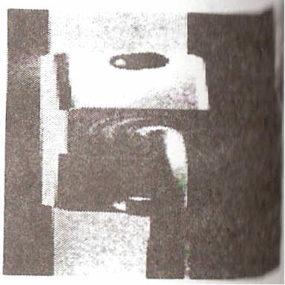Cable between the CPU and monitor may loose or fail.
* Software related problems.
* Failure in monitor s display electronics and in monitor's power supply.
* Incompatibility between software and display adapter.

Common symptom:

**No display.**

**Troubleshooting**

* Check the power to monitor.
* Check the brightness control on the monitor.
* Check the data cable between the monitor and the video port on the system unit.

**Problem**

* When the system turns on, it sounds a single beep and shows the disk activity (light flashes) but the display is blank.

**Solution**

* The computer is starting normally but the monitor doesn't display anything. Just use the following simple method.

**Methods**

* Shutdown the PC [unplug the power cable] and press down the video card firmly, restart the PC.
* Is the monitor turned on? If not, check the monitor power connector.
* If the problem is on the monitor, use the replacement method.
* Also check the connection (data cable) between the video card and the monitor.
* Your adapter hardware may not work, so use the replacement method.

**Problem**

* The Monitor shows only one bright vertical line in the center of the screen

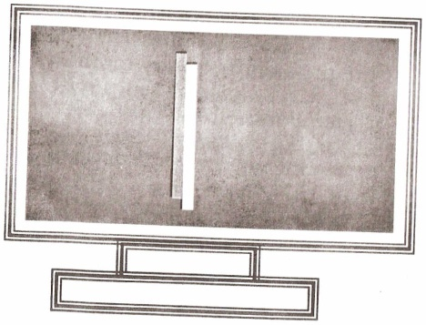

**Solution**

* The monitor is una\Jle to drag the ray (beam) to the horizontal side.
* There is a -problem on the horizontal section of the monitor circuit board.
* This symptom may also be the horizontal deflection' coil or its connection opened. However, unsolder the horizontal transistor from its board and measure it by using a multi-meter. [Usually Done by an electronics expert]

**Problem**

* The Monitor shows only one bright horizontal line in the center of the screen.

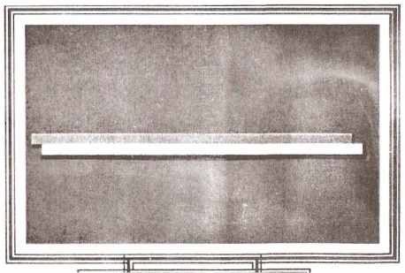

**Solution**

* The monitor is unable to pull the beam to the vertical the vertical side
* There is a problem in the vertical section [vertical IC].
* Cable between the CPU and monitor might fail or disconnected.
* Display adapter fault.
* Supply to vertical section is missing.
* Vertical deflection coil or its connection IS opened.

**Problem**

* The Monitor shows only one bright point in the center of the screen

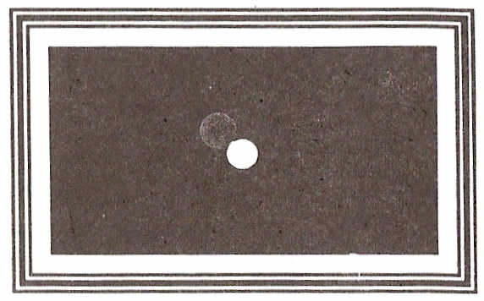

**Solution**

* The monitor is unable to pull the beam to horizontal and vertical side of the monitor.
* Check the horizontal transistor and vertical IC.

**Problem**

* No Power light appears on the Computer (Monitor &. System Unit) and

there is no display on the screen.

**Solution**

* Check the power line from the wall outlet.
* Check the adapter sockets.
* Check the power cables.
* Check that the system unit's power supply is plugged into the wall outlet (adapter socket)
* Check that the monitor is plugged into the wall outlet (adapter socket).
* Check the system unit's ON\ OFF switch.
* Check the monitor's ON\OFF switch.

**Problem**

* Still black screen, no power light and no fan sounds.

**Solution**

* Both the system unit and the monitor not getting power properly.
* Is it plugged in?
* Is the wall outlet power working?
* Or Computer's power supply has gone bad

**Problem**

* System unit's power lights, fan sound and no power light on the monitor.

**Solution**

* Check the monitor power connection.
* Use the replacement method.

**Problem**

* Both the monitor's and the system unit's power lights but no picture on the screen.

**Solution**

**Note:** The *red* power light on the monitor indicates *'no signal’* has been sent to the monitor through the monitor's data cable, and the *green* light indicates: that the monitor has received a signal from the CPU.

* Check if the monitor brightness and contrast is on accurate setting.
* Re-attach the data cable. The data (video) cable that connects the monitor to the video card may be unplugged.

**Problem**

* Still the monitor and computer system Power lights came on but there is no picture on the screen.

**Solution**

* Reseat the video card firmly. [Don't forget ESD]
* The video cable (pins) might fail. [So check it]
* The video card might fail. [Replace it]
* The monitor might fail.
* Use the replacement method.

**Problem**

* The computer shows "keyboard error" message on black screen or you couldn’t' type anything.

**Solution**

* + - * Check the keyboard connection (Identify t.: keyboard and the mouse connector (PS /2 types) at the back of your PC].
      * Unplug and re-plug the keyboard cable to make sure it is plugged in firmly.
      * Make sure that nothing is holding any key down on the keyboard.
      * Or the keyboard might fail. Use the replacement method.

**Problem**

* A PC shuts down and reboots without warning.

**Solution**

* Fluctuation in voltage would cause sudden restart *or shutdown.*
* Heat problem could cause restart after a few minutes of operation.
* Check the power supply fan.
* Check the CPU cooling fan.
* Check also the thermal compound [grease] between the CPU chipset and heat sink.